चित्र देखकर वाक्य लिखो **| C.W**

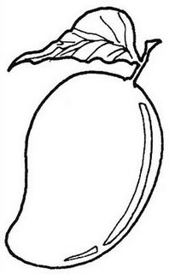

--------------------------------------------------------------------------------------------------------------------------------------------------------------------------------------------------------------------------------------------------------------------------------------------------------------------------------------------------------------------------------------------------------------------------------------------------------------------------------------------------------------------------------------------------------------------------------------------------------------------------------------

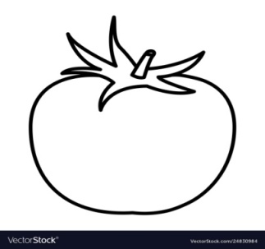

--------------------------------------------------------------------------------------------------------------------------------------------------------------------------------------------------------------------------------------------------------------------------------------------------------------------------------------------------------------------------------------------------------------------------------------------------------------------------------------------------------------------------------------------------------------------------------------------------------------------------------------------------------------------

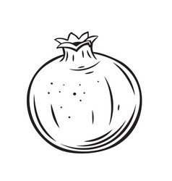

--------------------------------------------------------------------------------------------------------------------------------------------------------------------------------------------------------------------------------------------------------------------------------------------------------------------------------------------------------------------------------------------------------------------------------------------------------------------------------------------------------------------------------------------------------------------------------------------------------------------------------------------------------------------

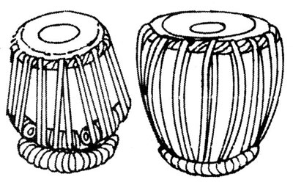

--------------------------------------------------------------------------------------------------------------------------------------------------------------------------------------------------------------------------------------------------------------------------------------------------------------------------------------------------------------------------------------------------------------------------------------------------------------------------------------------------------------------------------------------------------------------------------------------------------------------------------------------------------------------

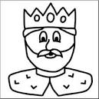

--------------------------------------------------------------------------------------------------------------------------------------------------------------------------------------------------------------------------------------------------------------------------------------------------------------------------------------------------------------------------------------------------------------------------------------------------------------------------------------------------------------------------------------------------------------------------------------------------------------------------------------------------------------------

चित्र देखकर वाक्य लिखो | **H.W**





